**EVA HESSE  
Three Pieces Plus...**The Guggenheim Art Gallery, New York.

In one corner of the room is a mass of tangled rope suspended from the ceiling with some sections dangling to the floor;  
the first of three encountered pieces of work that have a resounding impact on the viewing public.  
It stops one in one's tracks: how dare it be there - this mess of nothing! It is like arranged chaos: that is, the confused mixture of varying sizes of rope, dipped in latex, looks as though it might collapse in a heap on the floor at any moment. At the same time, it is held up and in place by a series of fine wires and hooks, giving it a strange sense of ... order.  
A deliberate challenge to the forces of gravity. It is a shambles. It makes one laugh. It is play. It is drawing in the air! Maybe it can move or dance about! Yet, it is hardly there, like something imagined.  
  
The materials are cheap and disposable. Impermanent, like ... the people looking at it. But it is very definitely present! It has a presence. You can see that people want to walk into it and become a part of it - but alas! The gallery guard is hovering nearby.

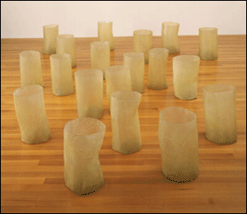

*Image courtesy of The Estate of Eva Hesse  
Galerie Hauser & Wirth, Zurich.*

To the left of this piece, running along the wall, in two rows on top of each other, is a long series of lid-less boxes. They are mounted at average nose height and are made of fibreglass which gives them a shiny, almost moist, appearance. They are the colour of murky water, absorbing the gallery light with an opacity similar to that of mucus or tree gum.  
  
They look as though they might be soft and malleable to touch, with their irregular edges and non-conforming sides. This gives the overall impression that they could fall in on themselves or slide down the wall. The structure is puzzlingly familiar, similar to things in the world, and yet it is not like anything in particular.

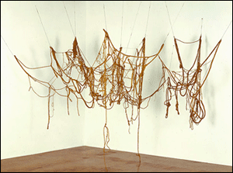

*Image courtesy of The Estate of Eva Hesse  
Galerie Hauser & Wirth, Zurich.*

In the adjacent corner is the third piece, consisting of a collection of nine cylindrical open-ended objects, slit part way from end to end. They give the appearance of being randomly placed - some lying, some leaning on the wall or on each other-all seeming somehow to be related. Like the boxes, they are a multiple of each other. Made of fibreglass with a shiny surface they look almost like abandoned pods that had once been alive. The associations seem to jump around in one's head, running between sensations of delight and pleasure, violence and discomfort.  
  
One has to bend down to be with them more. Driven by the desire to physically interact, one is almost forced to stoop further so that one can touch, or indeed taste, this intriguing surface; but no, the guard is there.  
  
The visual language apparent in these artworks is unfamiliar, as is the artist, Eva Hesse. Her work is as exciting as it is disturbing. For many, Hesse's sculpture refers essentially to the body. This, perhaps, does not seem surprising when it is in relation to the body that women are generally assessed. Hesse died of a brain tumour in 1970 at the age of 34. It must be an inescapable inevitability, therefore, that her work was read in the context of its time where it has, until recently, been largely abandoned.  
  
Given the influence of feminism on our cultural consciousness since that period, it seems paramount that we avoid, or at the very least attempt to avoid, those dramatic facts about her life and family history. We may then be freed from a limited and narrow translation of her art.  
  
Hesse's work is much more ambiguous and funny than some rather literal readings would have us believe. Perhaps it is precisely because her use of metaphor in her work is so subtle that it escapes the one-line definitions we so love to employ.  
  
We are now, more than ever, hungry for the cult of 'personality'. While Hesse and others before and since can more than fill that demand, we seem in danger of focusing on the life of the artist and not on the life of the art.  
  
When looking at Hesse's sculpture, drawings and paintings, the most interesting and challenging aspects lie just there - within the work. And this must be the starting point for any interpretation, not her complex life or untimely death.